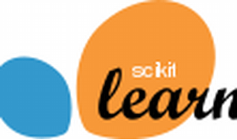

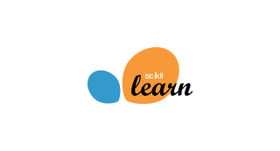

Explore

**Scikit-learn**, also known as **sklearn**, is a **Python library** for **machine learning**. It provides **simple and efficient tools** for predictive data analysis, making it accessible to everyone. You can use it for tasks like classification, regression, clustering, dimensionality reduction, and more. [Sklearn is built on **NumPy**, **SciPy**, and **matplotlib**, and it’s open source with a commercially usable BSD license1](https://scikit-learn.org/stable/index.html).

Here are **five free reference links** where you can learn more about scikit-learn:

1. [**Scikit-learn Official Documentation**](https://scikit-learn.org/stable/index.html): Dive into the official documentation to explore various functionalities and examples[1](https://scikit-learn.org/stable/index.html).
2. [**Scikit-learn Tutorials**](https://scikit-learn.org/stable/tutorial/index.html): Learn the basics of machine learning with practical examples and tutorials[2](https://scikit-learn.org/stable/tutorial/index.html).
3. [**An Introduction to Machine Learning with Scikit-learn**](https://scikit-learn.org/stable/tutorial/basic/tutorial.html): Understand the problem setting, loading datasets, and basic learning concepts[3](https://scikit-learn.org/stable/tutorial/basic/tutorial.html).
4. [**Getting Started with Scikit-learn**](https://scikit-learn.org/stable/getting_started.html): Explore the basics of fitting, predicting, and using estimators in scikit-learn[4](https://scikit-learn.org/stable/getting_started.html).
5. [**Scikit-learn External Resources**: Find additional videos, talks, and tutorials related to scikit-learn](https://scikit-learn.org/stable/index.html)[2](https://scikit-learn.org/stable/tutorial/index.html).

Happy learning! 🚀📚